Week 3 GOAL’s

Task: 1. Create a supplier table with the attributes given in the table below. You are expected to give each attribute a relevant name and data type, and to correctly define the primary key:

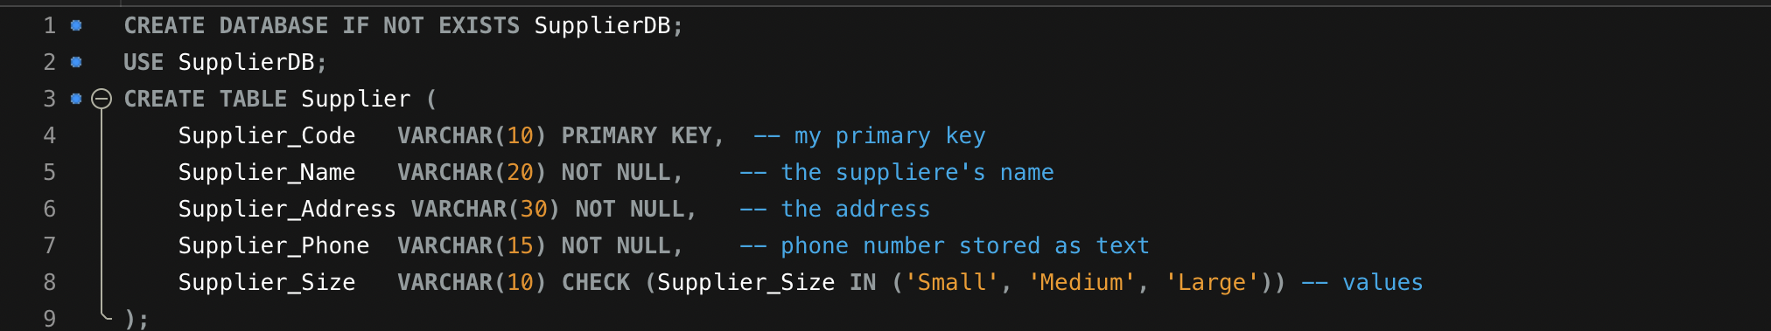

Explanation of my code:
- Started by creating the DB
- Supplier_Code: is Used as the Primary Key to ensures uniqueness.
- NOT NULL: Ensures Entity Integrity so theres no missing values.
- I used CHECK (Supplier_Size IN ('Small', 'Medium', 'Large')), to ensure only valid sizes are entered.

Task 2. Populate the table with at least 5 rows of data. Make sure the data is realistic and the Entity Integrity Constraint is not violated.

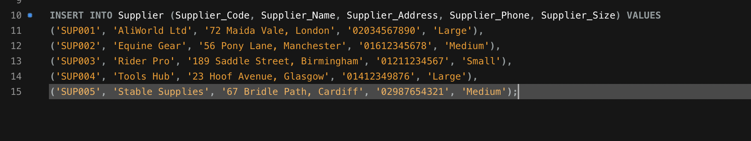

Use the supplier table to answer the following:

I3.1. The attributes have been given relevant names.
Attribute Name | Description
Supplier_Code | Unique identifier for the supplier
Supplier_Name | Name of the supplier
Supplier_Address | Address of the supplier
Supplier_Phone | Contact phone number
Supplier_Size | Supplier size (Small, Medium, Large)

I3.2. The attributes have relevant data types.
Attribute Name | Data Type | Justification
 | VARCHAR(10) | Ensures alphanumeric codes
  Supplier_Code
Supplier_Name | VARCHAR(20) | Stores short supplier names
Supplier_Address | VARCHAR(30) | Allows flexible address input
Supplier_Phone |  | Phone numbers are stored as text (can contain dashes/spaces)
  VARCHAR(15)
Supplier_Size |  | Limited to Small, Medium, Large
  VARCHAR(10)

I3.3. The create statement is correctly used:
The CREATE TABLE statement from my Task 1 is correct and defines the structure properly.
I3.4. The Primary key is correctly defined:
The primary key is defined as, Supplier_Code VARCHAR(10) PRIMARY KEY, and it ensures each supplier has a unique identifier and prevents duplicates.
I3.5. The Insert statement is correctly used:
My INSERT statements from Task 2 correctly add realistic supplier data without violating any integrity constraints.
screenshot of my inserted data:
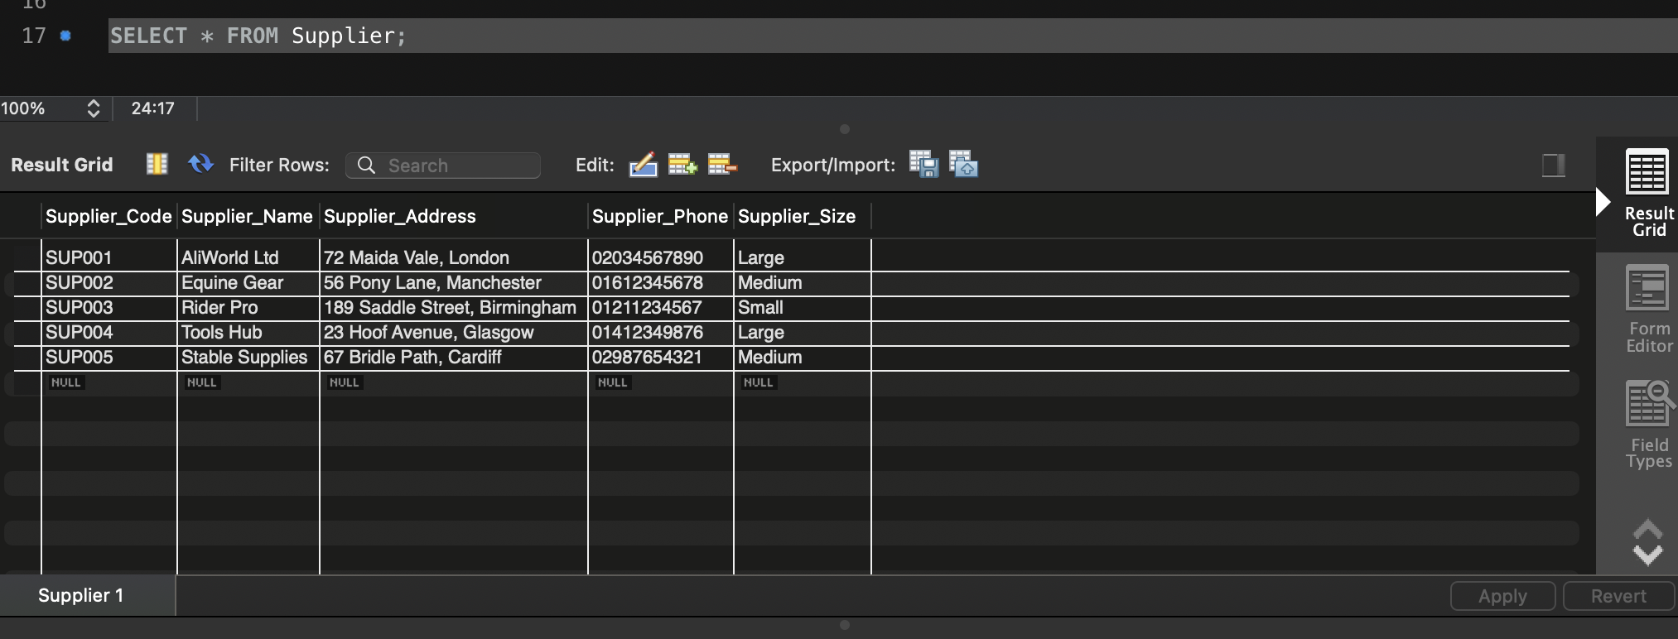

I3.6. Using the Supplier table as an example, discuss any relevant integrity constraints:
Integrity constraints in the Supplier table include:
- Entity Integrity: Supplier_Code is the Primary Key, ensuring unique values.
- Domain Integrity: Supplier_Size is restricted to 'Small', 'Medium', or 'Large' using CHECK.
- NOT NULL Constraints: Ensures critical fields (Supplier_Name, Supplier_Address, Supplier_Phone) are never empty.

I3.7. Write a SQL statement to add an extra attribute, of your choice, to the Supplier Table:
For this GOAL I added a "Email" column to store supplier emails:
I run (ALTER TABLE Supplier ADD Supplier_Email VARCHAR(50);)

Screenshot using (DESCRIBE Supplier;) after running this:

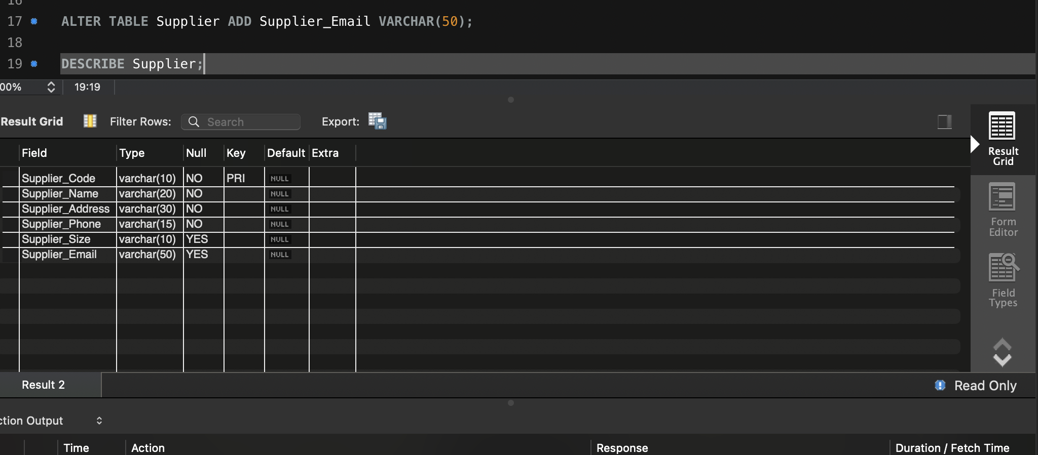

I3.8. Write a SQL statement to change the data type of the “Supplier’s phone number” attribute from text to number:
To change the data type of the “Supplier’s phone number” attribute from text to number I changed it to BIGINT:
I run (ALTER TABLE Supplier MODIFY Supplier_Phone BIGINT ;)

Screenshot using (DESCRIBE Supplier;) after running this:

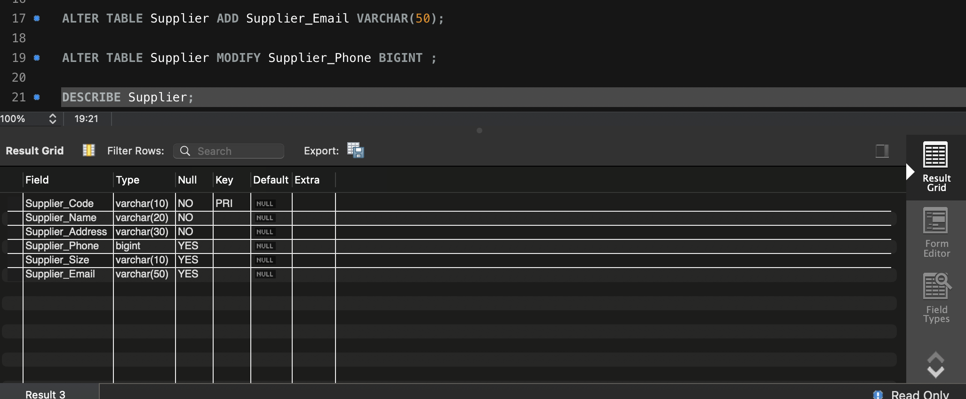

I3.9. Write a SQL statement to add a check constraint to “Supplier size” attribute in the Supplier Table:
Even though I added a constraint at the start, let's ensure check is enforced:

I run (ALTER TABLE Supplier ADD CONSTRAINT chk_supplier_size CHECK (Supplier_Size IN ('Small', 'Medium', 'Large'));)

I3.10. Write a SQL statement to delete an attribute, of your choice, from the Supplier Table:
I decided to remove the "Supplier Email" column:
I run (ALTER TABLE Supplier DROP COLUMN Supplier_Email;)

Screenshot using (DESCRIBE Supplier;) after running this:

